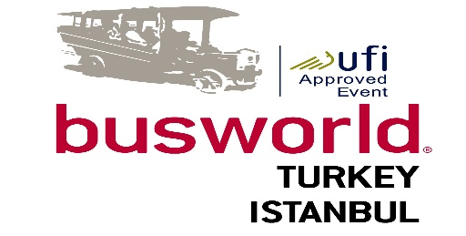
BUSWORLD TURKEY
14 – 17 April 2016
ISTANBUL EXPO CENTER, Yesilkoy, Istanbul, TURKEY
Buyer Application Form

COMPANY PROFILE
 | Company:
 | Surname: | Name:
 | Position in the company:
 | Address:
 | City/ZIP: Country:
 | Phone: | Fax:
 | E-mail: | Mobile:
 | Web Site: | No. Of employees:
 | Turnover: | Year of foundation:
Specify your activity: (please tick ALL that apply):
Company Owner/Executive
Investor
Plant and Production Manager
R&D Manager
Technical Manager and Engineer
Purchase Department Manager
Quality Control Manager
Laboratory Officer
Other distribution / trade agencies
National / local authorities / Government official
Other/ (Please Specify) ………………………………………………………………………………..

